Volume Spread Analysis

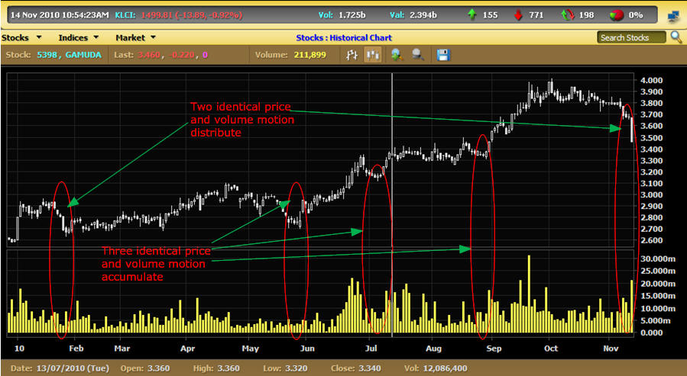

Volume spread analysis originates from history that repeat itself. It is a three dimensional movement that involve price, volume and time. Repeated history could be the fourth dimensional. Volume Spread Analysis is based on four price movement:

* Accumulate
* Mark Up
* Distribute
* Mark Down

The volume motion and quantity evolve something like below both for uptrend and downtrend even though must not necessarily happened like that.

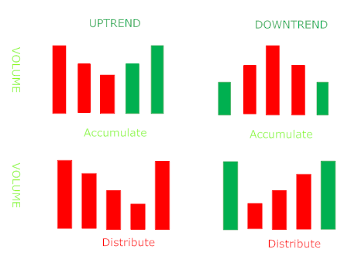

When accumulation happens there are few things to look for :
* Volume should be low and quite, no huge volume upsurges. Even when volume is high volume during morning and evening might not differ much.
* High price and low price not differ much the candlestick body is short
* When the price arrive at support volume should shrink while arriving at resistance volume should expand (for down trend it is reverses)
* Trading takes quite along time

Accumulation is shaking out the weak money where the traders ill interpret this as fails upsurges break out. The next phase after accumulation would be Mark Up. When there is less supply the prices are getting higher and higher on lower volumes. When volume becomes really high the price will shoot up the resistance line the stock suddenly pop out from its congestion zone. There will also be sideways movement during Mark Up which is the congestion area.

Increasing volume near support line and low pivots indicate problem.

Too much volume is not good it would mean too much supply is coming in. Typically 150% increase in volume close the top indicate a successful breakout. During Mark Up the stock is making higher high and lower low.

The third phase is the Distribution phase. It is a process where traders is off load their accumulated stock at much higher price. During the final run of Mark Up the angle of ascending is becoming lower and lower and the trend is getting flat again. The demand is drying up but supply is flourishing. Prices are support at certain levels then the stock drop like a falling rock. You will see the Head and Shoulder or devils horn kind of pattern.

The Mark Down is the downtrend of an uptrend some people say that it is a falling knife. The volume is more when price getting lower but low when price getting higher. It my take weeks before it touches the lowest bottom. It is during this time you would see rallies in the form of dead cat where volume pattern is the most important. Mark Down is the gold for short time traders since it offers many opportunity to enter into some profitable stock market.

Volume Spread (VSA) analyze three respect of dimensions volume, spread and close. However open price is not counted. Some definitions need to be understood before volume spread analyze can be continued.

Upbar: When the closing price of today's bar is above the closing price of yesterday's bar.

Downbar: When the closing price of today's bar is below the closing price of yesterday's bar.

Spread: Difference between high and low price

Wide spread bar: 1.8 times larger than the average spread

Narrow Spread bar: 0.8 times the average spread

Close positions can be related to the Japanese Candlestick chart patterns. Hammer - Up close, Spinning Top - Mid close and Graveyard - Down close.

VSA measures strength and weaknesses of each bar. Always look for weakness in uptrend and strength in a down trend based on Spread and Volume.

Start looking for a Up thrust bar for it is the sign of marking up price since it appears after a wide range Upbar with high volume. What is an Up thrust bar? It is a wide range bar with high volume and closing down. Most of the time it will be moving to a new high territory. The high price of this bar to day is higher than yesterday. Always notice the following during Up thrust:

* High volume and how high
* Wide spread
* Previous bar action
* Enter new territory
* Close, near or low
* Uptrend or downtrend

The higher the volume the weaker the bar indicates. The wide the spread the more powerful it is. The lower the closing price the weaker the bar. The Japanese candlestick chart pattern is the Graveyard if it the spinning top the price is not going to move down. Up thrust with low volume is called Pseudo Up thrust. Important steps:

The moment you see an Up thrust what is your next move?

The next bar beside Up thrust is the most important. If the next bar is the Downbar confirmed the price weakness the immediate trend is about to reverse. Plus high volume it is better that the trader make decision to get out of the market. If accompanied by low volume it is better to wait. Other clues are spread and position of the bar. Weakness is enhanced when the close price is near to the low price of he Up thrust bar. If the volume is low but the close price of up thrust bar near the high price of the second bar wait for the third bar to come.

No Demand Bar

No demand bar is an Up bar with narrow spread closing near the middle or lower volume of that bar is lesser than the previous bar. It indicates that trader are not supporting the price on no demand bar. This will indicate that no higher prices will go above than the no demand bar. No demand bar is equivalent to Doji in the Japanese Candlestick Chart pattern. Doji creates uncertainty but we have to look over the background that reflects weaknesses in terms of Up thrust or Pseudo Up thrust. It will be an enhanced weaknesses if the background has already weaknesses indicator. Otherwise wait because traders cannot make decision whether they should enter the market or not. Remember three basic principles:

* Price and volume
* Cause and effect
* Effort and result

Price and volume always moves parallel to each other but never cross each other. The effect of an up thrust is the cause of high demand but less supply. The effort and result is the effort to move up where bar open near low but close up near high in contradiction to effort without result where effort to move the bar high ended with closing near low but large supply swamping the demand resulted as effort without result. Later the price stock will be testing for supply. Testing for supply is looking for supply until supply has drained (sellers). In an uptrend if the stock could not find supply the stock will pause for a while before it descend lower. Testing for supply is done by rapidly marking down the price to a certain level called support line.

- If the stock moves high but volume stays low it means there is no supply for the stock.
- If volume is high but stock remains low it means that supply still present.
- Low volume with less activity indicates a successful test.

Stopping Volume

After a long downtrend the downtrend might end up with high volume and a hammer. The chart might go sideways for accumulation before another up trend begin. This volume is called the stopping volume.

Support and resistance clusters

There could not be only one price considered as resistance or support there should be clusters of resistance and clusters of support. Clusters of support can be considered support if the swing lows have price reacted at these levels. Similarly swing highs are cluster of resistance if the price are being acted upon.

Difference between reversals and retracement

One should look over the trend as retracement or reversal before making any decision to buy or sell. You would be giving too much if the retracement is considered as reversal or vice versa. The basic things for retracement or reversal is:

Retracement
* Lack of volatility
* Small Spreads
* Decreased volume

Reversal
* Increased volatility
* Large spreads
* Increasing volume

Conclusions

* In retracement arrows for stock movement and arrows for volume are in the same direction but reversals will have opposite directions.
* Most conflicts between the bulls and the bears occur in the middle between resistance and support zone. This is the most important arena for stock market surges up or surges down. This is the area where volumes plays the most important factor.
* Substantial buying has already happened at low levels of the price stock but real professionals will do buying on the down bar with volume spike.
* Down bar is the power of strength while the up bar is the weakness.
* Low demand but high supply is causing downtrend to happen.
* Professional buyers do the selling on up bar cause it to be weak before no buyers can support the existing price that it falls until mark down phase is over.
* When there is bad news many people start to sell that it creates opportunities for professional buyers to buy and this happen on down bars.
* The most famous up bar movement is from price closes at the middle with volume spike (spinning top) this signifies transfer of ownership from professional sellers to weak buyers ----> price closes at the top with little lower volume than previous (hanging man) ----> price closes at the top signifies that more selling than buying (inverted hammer) volume more lower than previous ----> money is in the hand of the weak buyers ----> Professional buyers has stop trading causing mark down.
* Professional buyers will continue to buy after the mark down has got its support line.
* Two important questions over market movement is why and when.
* Why markets surge up or surge down is based on supply and demand from professional buyers or professional sellers.
* As to when the price get spread is the understanding over matters regarding volume spread analysis.

